

**Wildlife Project**

By:

Devomech Solutions Pvt. Ltd.

Date:19-05-2023

# Current Progress:

* The ESp32 resets after wakeup by RTC alarm from deep sleep, due to which the data posted flag was not set low in the overall flow, the problem was resolved by saving the posted date in non-volatile memory. The overall flow is as followed

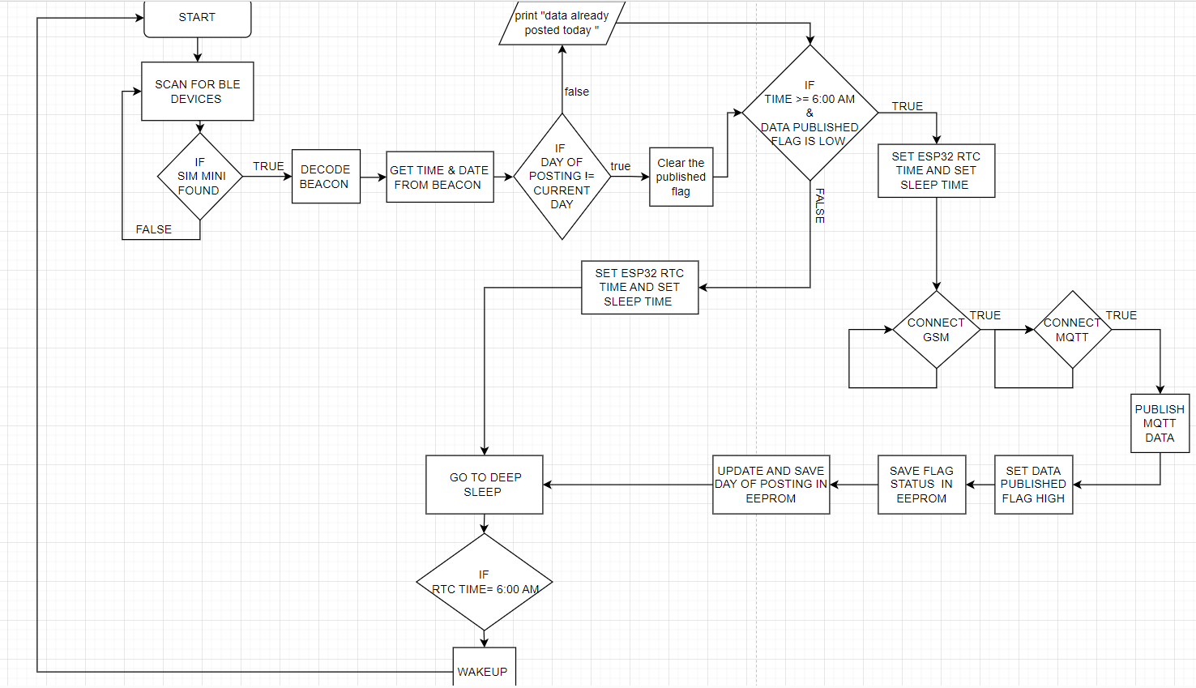

*Figure 1 FLOW DIAGRAM*

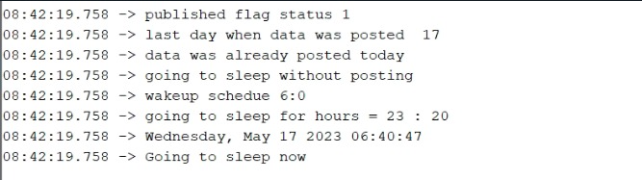

*Figure 2 Posting logs*

* Previously every single information was being sent in separate topic with separate key, which will cause problem when multiple devices will send data in cluster, now every device sends the information to MQTT broker in single topic with the topic key defined by the Device name.

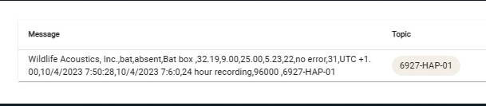

*Figure 3 Web server*

## HIVE MQ broker

We have chosen HiveMQ broker because of the following reason

1. **Scalability**: It is designed to handle large-scale deployments with thousands or even millions of connected devices.
2. **Reliability and Stability**: It offers features like clustering and high availability, ensuring that message delivery is not affected by failures or network interruptions.
3. **Security**: HiveMQ offers robust security features, including support for Transport Layer Security (TLS) encryption and authentication mechanisms like username/password and client certificate-based authentication.
4. **Popular HiveMQ users**: HiveMQ has millions of customers worldwide including BMW, NETFLIX, BEATS, Mercedes-Benzes, and SIEMENS etc.

## PC Application

* The PC Application is connected to the broker using Paho MQTT Client Library.
* The application will run indefinitely and will reconnect automatically if connection drops.
* Data received from any device will be written to its respective CSV file automatically.
* Each data row in the csv is prefixed by the timestamp for when the data was received.

# Tasks for next week

* To be decided after discussion